Create the code to represent the following diagram including building relationships where required.

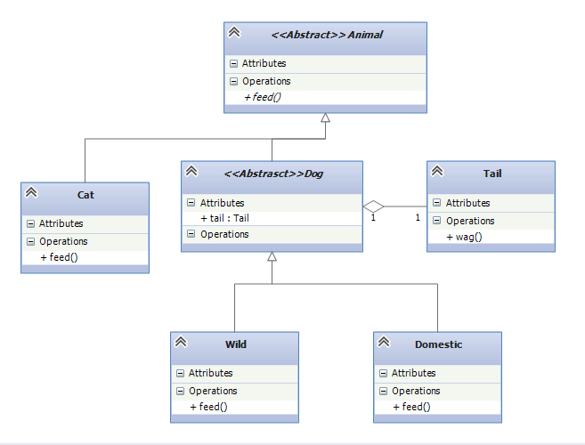

### Notes:

* *The method feed() in Animal is abstract*
* *The methods in the classes should print the name of the class and the name of the method to the console eg Cat feed() or Tail wag()*
* *In addition to this, the feed() method in Domestic should call the wag() method in Tail*
* *Using* ***Animal object references****, test the feed() method for objects of Cat, Domestic and Wild*